Distributed Collaborative Key Management System for Dynamic Peer Groups

Dr. R. Shanmugalakhsmi , Assistant Professor ,M.E, Ph.D, M. Prabhu and S. Rajesh Kumar, Final year Student, B.E .
ABSTRACT:

With the emergence of many group-oriented distributed applications such as tele -video-conferencing and multiplayer games, there is a need for security services to provide group-oriented communication privacy and data integrity. To provide this form of group communication privacy, it is important that members of the group can establish a common secret key for encrypting group communication data. In this paper several distributed collaborative key agreement protocols for dynamic peer groups are discussed. There are several important characteristics which make this problem different from traditional secure group communication. They are: i) Distributed nature in which there is no centralized key server, ii) Collaborative nature in which the group key is contributory (i.e., each group member will collaboratively contribute its part to the global group key) and iii) Dynamic nature in which existing members may leave the group while new members may join. Instead of performing individual rekeying operations, i.e., recomputing the group key after every join or leave request, an interval based approach of rekeying is discussed. Two interval-based distributed rekeying algorithms for updating the group key are considered. They are 1) the Rebuild algorithm; 2) the Queue-batch algorithm. The interval-based algorithms significantly outperform the individual rekeying approach. These algorithms can substantially reduce the computation and communication workload in a highly dynamic environment. This work provides a fundamental understanding about establishing a group key via

distributed and collaborative approach for a dynamic peer group.

KEY WORDS:

Dynamic peer groups, group key agreement, rekeying, secure group communication and security.

- INTRODUCTION

With the advent of internet as the main platform for providing services, there is a need to provide secure communication. To provide this form of group communication privacy, it is important that members of the group can establish a common secret key for encrypting group communication data. To illustrate the utility of this type of applications, consider a group of people in a peer-to-peer or ad hoc network having a closed and confidential meeting. Since they do not have a previously agreed upon common secret key, communication between group members is susceptible to eavesdropping. To solve the problem, one needs a secure distributed group key agreement protocol so that people can establish and authenticate a common group key for secure and private communication. Note that this type of key agreement protocols is both distributed and contributory in nature. Each member of the group contributes its part to the overall group key. It is important to point out that the type of distributed group key agreement protocols is very different from traditional centralized group key management protocols. Centralized protocols rely on a centralized key server to efficiently distribute the group key. In those approaches, group members are arranged in a logical key hierarchy known as a key tree. Using the tree topology, it is easy to distribute the group key to members whenever there is any change in the group membership (e.g., a new member joins or an existing member leaves the group).
In the distributed key agreement protocols considered here, there is no centralized key server available. This arrangement is justified in many situations—e.g., in peer-to-peer or ad hoc networks where centralized resources are not readily available. Moreover, an advantage of distributed protocols over the centralized protocols is the increase in system reliability, because the group key is generated in a shared and contributory fashion and there is no single-point-of-failure. In the special case of a communication group having only two members, these members can create a group key using the Diffie–Hellman key exchange protocol. In the protocol, members and use a cyclic group of prime order with the generator. They can generate their secret exponents and respectively. Members can compute their public key and send it to other members .Since both members know their own exponent, they can each raise the other party’s public key to the exponent and produce a common group key. Using the common group key, and can encrypt their data to prevent eavesdropping by intruders. In this paper proposals based on the tree-based group Diffie–Hellman protocol, several group key agreement protocols for a dynamic communication group in which members are located in a distributed fashion and can join and leave the group at any time have been made.

• Instead of using individual rekeying operations, an proposal for Interval-based distributed rekeying algorithms. The interval-based approach provides rekeying efficiency for dynamic peer groups while preserving both distributed (i.e., no centralized key server is involved) and contributory (i.e., each member contributes to the resulting group key) properties.

• A comparison of interval based rekeying approach and centralized key management is made.

• An implementation called the SEcure Communication Library (SEAL) that realizes the interval-based algorithms is done. The library provides a programming interface for the development of secure group-based applications.

2. TREE BASED GROUP DIFFIE HELLMAN PROTOCOL

Tree based Diffie Hellman protocol[1] is basically an extension of Diffie Hellman key exchange for two members. A brief overview of Diffie Hellman key exchange protocol is presented here:

2.1 DIFFIE HELLMAN KEY EXCHANGE PROTOCOL

In the special case of a communication group having only two members, these members can create a group key using the Diffie Hellman[3] key exchange protocol. In the protocol, members and use a cyclic group of prime order with the generator. They can generate their secret exponents and respectively. Members can compute their public key and send it to other members .Since both members know their own exponent, they can each raise the other party’s public key to the exponent and produce a common group key. The group key K_{v} can be calculated as follows after key exchange:

Kv=(Received Public Key) ^{(Own Private Key)} mod p

Where p is the prime number. Using the common group key, and can encrypt their data to prevent eavesdropping by intruders. In this paper proposals based on the tree-based group Diffie Hellman protocol, several group key agreement protocols for a dynamic communication group in which members are located in a distributed fashion and can join and leave the group at any time have been made.

2.2 GROUP KEY AGREEMENT USING TGDH

To efficiently maintain the group key in a dynamic peer group with more than two members, the tree based group Diffie-Hellman (TGDH) protocol proposed. Each member maintains a set of keys, which are arranged in hierarchical binary tree. A node ID_{v} is to every tree node. For a given node v, there is a secret (or private) key K_{v} and a blinded (or public) key BK_{v}. All arithmetic operations are performed in a cyclic group of prime order p with the generator α. Therefore, the blinded key of node v can be generated by

BK_{v} = α ^{Kv} mod p

Each leaf node in the tree corresponds to the individual secret and blinded keys of a group member M_{i}. Every member holds all the secret keys along its key path starting from its associated leaf node up to the root node. Therefore, the secret key held by the root node is shared by all the members and is regarded as the group key. Figure.2.1 illustrates a possible key tree with six members M₁ to M₆. For example, member M₁ holds the keys at nodes 7,3,1 and 0. The secret key at node 0 is the group key of this peer group.
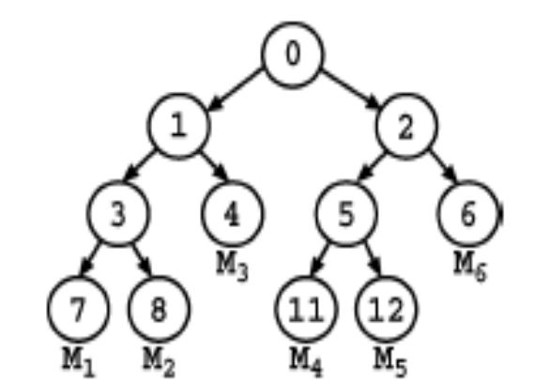
Figure 2.1 Key Tree used in TGDH Protocol

The node ID of the root node is set to 0. Each non leaf node v consists of two child nodes whose node ID’s are given by 2v+1 and 2v+2. Based on the Diffie Hellman protocol, the secret key of a nonleaf node v can be generated by the secret key of one child node of v and the blinded key of another child node of v. Mathematically, it is evident that,

K_{v} = (BK_{2v+1}) ^{K}_{2v+2} mod p
= (BK_{2v+2}) ^{K}_{2v+1} mod p
= α ^{K}_{2v+1} ^{K}_{2v+2} mod p
Unlike the keys at non leaf nodes, the secret key at a leaf node is selected by its corresponding group member through a secure pseudo random number generator.

Since the blinded keys are publicly known, every member can compute the keys along its key path to the root node based on its individual secret key. To illustrate, consider the key tree in Figure.2.2. Every member M_{i} generates its own secret key and all the secret keys along the path to the root node. For example, member M₁ generates K₇ the secret and it can request the blinded key BK₈ from M₂, BK₄ from M₃ and BK₂ from M4, M₅ or M₆.Given M₁’s secret key K₇ and the blinded key BK₈, M₁ can generate the secret key K₃. Given the blinded key BK₄ and the newly generated secret key K₃, M₁ can generate the secret key K₁. Given the secret key K₁ and the blinded key BK₂, M₁ can generate the secret key K₀ at the root. From that point on, any communication in the group can be encrypted based on the secret key (or group key) K₀.
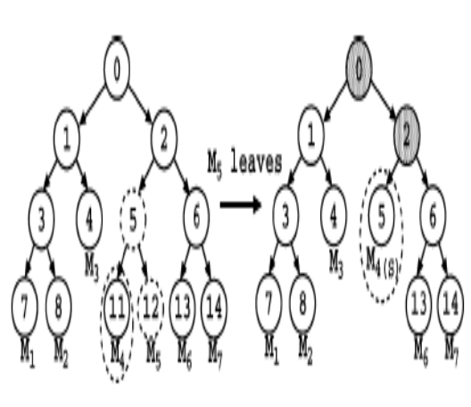
Figure 2.2 Membership Leave Event

To provide both backward confidentially (i.e., joined members cannot access previous communication data) and forward confidentially (i.e., left members cannot access future communication data), rekeying, which means renewing the keys associated with the nodes of the key tree, is performed whenever there is any group membership change including any new member joining or any existing member leaving the group. Let us first consider individual rekeying, meaning that rekeying is performed after every single join or leave event. Figure.2.2 depicts a member leave event. Suppose that member M₅ leaves the system. Node 11 is then promoted to node 5, and nodes 2 and 0 become renewed nodes, defined as the non leaf nodes whose associated keys in the key tree are renewed. Also, member M₄ renews the secret keys K₂ and K₀ .
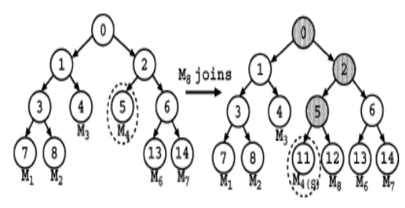
Figure 2.3 Membership Join Event

Figure.2.3 illustrates a new member M₈ that wishes to join the group. M₈ has to first determine the insertion node under which M₈ can be inserted. To add a node, say v' (or tree, say T’) to the insertion node, a new node, say n’, is first created. Then the subtree rooted at the insertion node becomes the left child of the node n’, and the node v' (or the root node of the tree T’) becomes the right child of the node n’. The node n’ will replace the original location of the insertion node. The insertion node is either the rightmost shallowest position such that the join does not increase the tree height or the root node if the tree is initially well balanced (in this case, the height of the resulting tree will be increased by 1).

Based on the above leave and join events in Figure 2.2 and Figure 2.3, one can find that one rekeying operation can be reduced if one can simply change the association of node 12 from M₅ to M₈. Interval-based rekeying is thus proposed such that rekeying is performed on a batch of join and leave requests so as to reduce the number of rekeying operations. Members carry out rekeying operations at regular rekeying intervals.

3. INTERVAL BASED REKEYING

As discussed earlier TGDH rekeying is done for every join and leave event, but Interval-based rekeying maintains the rekeying frequency regardless of the dynamics of join and leave events, with a tradeoff of weakening both backward and forward confidentialities as a result of delaying the update of the group key. A implementation interval-based distributed rekeying algorithms termed the Rebuild algorithm[1] and the Queue-batch algorithm[1]. Interval based algorithms provide better efficiency than individual rekeying with the increase in the number of membership events.

3.1 ASSUMPTIONS

The interval-based algorithms are developed based on the following assumptions:

- All members are trusted in the key establishment process.

- The group communication satisfies view synchrony [6] that defines reliable and ordered message delivery under the same membership view. Intuitively, when a member broadcasts a message under a membership view, the message is delivered to same set of members viewed by the sender. Note that this view-synchrony property is essential not only for group key agreement, but also for reliable multipoint-to-multipoint group communication in which every member can be a sender.

- Rekeying operations of all members are synchronized to be carried out at the beginning of every rekeying interval.
- When a new member sends a join request, it also includes its individual blinded key.
- All members know the existing key tree structure and all the blinded keys within the tree.
- All messages are delivered in the order which they are sent.

The following notations are adopted in our description. Let T denote the existing key tree. Assume L ≥ 0 that existing members M^{L} = {M₁, M₂,…., M_{L}} wish to leave and J ≥ 0 new members M^{J} = {M₁, M₂,…., M_{J}} wish to join the group within a rekeying interval.

  - KEY TREE CONSTRUCTION
A linear-time method to create a key tree is to use a queue. This assures that the tree height is kept has minimum as possible. M is a set of members of a group. The algorithm used to construct a key tree is given below
CONSTRUCT KEY TREE ( M ):
1. Start with as many leaves as there are members.
- Enqueue all leaf nodes into the queue.
- While there is more than one node in the queue:
  - Dequeue the latest two nodes.
  - Create a new internal node with the two nodes which were just removed as its children (the order in which the nodes are attached to the parent is irrelevant).
  - Peform any computations that are required for assigning values to parent node from its children.
  - Enqueue the new node into the rear end of the queue.
- Dequeue the remaining one from the queue
- Assign it to the root of the key tree.

3.3 REBUILD ALGORITHM

The motivation of the Rebuild algorithm is to minimize the resulting tree height so that the rekeying operations for each group member can be reduced. At the beginning of every rekeying interval, one reconstructs the whole key tree with all existing members that remain in the communication group, together with the newly joining members. The resulting tree is a left-complete tree, in which the depths of the leaf nodes differ by at most one and those deeper leaf nodes are located at the leftmost positions. The pseudo code of the Rebuild algorithm to be performed by every member is given below

REBUILD (T, M ^{J}, J, M ^{L}, L)
- Obtain all members from T and store them in M’
- Remove the L leaving members in M ^{l} from M’
- Add the J new members in M ^{j} to M’
- Create a new binary tree T’ based on members in M’ and set T = T’
- Elect all members to be sponsors
- Rekey renewed nodes and broadcast new blinded keys in T

Figure 3.1 shows the scenario where members leave and a new member joins the communication group. Based on the algorithm, the resulting key tree consists of five members and has all non-leaf nodes renewed.

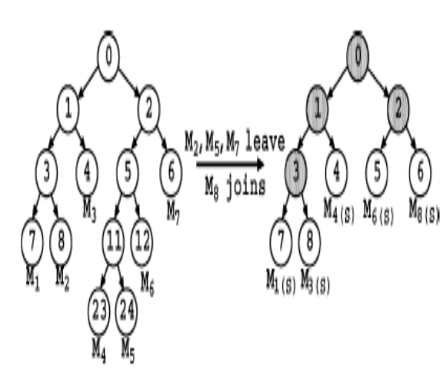
Figure 3.1 Illustration of Rebuild Algorithm

Rebuild is suitable for some cases, such as when the membership events are so frequent that one can directly reconstruct the whole key tree for simplicity, or when some members lose the rekeying information and the simplest way of recovery is to rebuild the key tree.

3.4 QUEUE BATCH ALGORITHM

The previous approach performs all rekeying steps at the beginning of every rekeying interval. This results in high processing load during the update instance and thereby delays the start of the secure group communication. A more effective algorithm called the Queue-batch algorithm is used to reduce the rekeying load. Its intuition is to reduce the rekeying load by pre-processing the joining members during the idle rekeying interval. The Queue-batch algorithm is divided into two phases, namely the Queue subtree phase and the Queue-merge phase.

The first phase occurs whenever a new member joins the communication group during the rekeying interval. In this case, one appends this new member in a temporary key tree. The second phase occurs at the beginning of every rekeying interval and merges the temporary tree (which contains all newly joining members) to the existing key tree. The pseudo-codes of the Queue subtree phase and the Queue-merge phase are given below
QUEUE-SUBTREE (T’)
- if (A new member joins)
- if (T’ == NULL) /* no new members in T’ */
- Create a new tree T’ with the only one new member;
- else /* there are new members in T’ */
- Find the insertion node
- Add the new member to T’
- Rekey renewed nodes
QUEUE-MERGE (T , T’ , M ^{l}, L)
- if (L == 0) {/* there is no leave */
- Add T’ to either the shallowest node (which need not be the leaf node) of T such that the merge will not increase the resulting tree height, or the root node of T if the merge to any locations will increase the resulting tree height
- } else { /* there are leaves */
- Add T’ to the highest leave position of the key tree T
- Remove remaining L -1 leaving leaf nodes and promote their siblings
- }
- Rekey renewed nodes

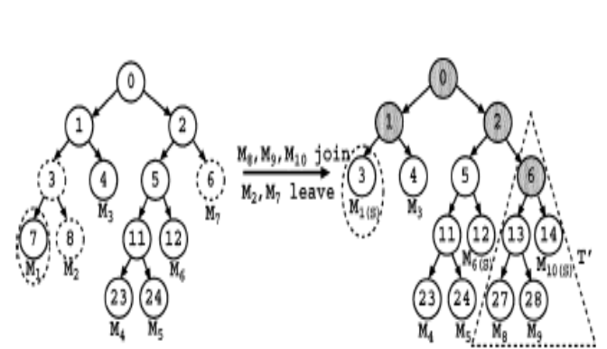
Figure 3.2 Illustration of Queue Batch Algorithm

The Queue-batch algorithm is illustrated in Figure 3.2, where members M₈, M₉ and M₁₀ wish to join the communication group, while M₂ and M₇ wish to leave. Then the rekeying process is as follows:

1. In the Queue subtree phase, the three new members, and first form a tree. The temprorary tree constructed is called T’.

2. In the Queue-merge phase, the tree is added at the shallowest position, which is at node 6.

3. Rekeying is done nodes that lie along the path to the root for those leaf nodes where there has been a change.

4. Finally, all members can compute the group key.

4. CENTRALIZED VERSUS DECENTRALIZED GROUP KEY MANAGEMENT

In this section, a comparison of centralized logical key tree (LKT) and interval based algorithms is made. Similar to the interval-based algorithms, there is a key tree in the LKT approach is a binary tree and that the keys of the tree nodes are computed based on the TGDH protocol. Among the group’s members, a group controller is selected that centrally renews the group key at periodic rekeying intervals. The group controller knows the keys of all the nodes in the key tree and that a newly joining member sends its individual secret key to the group controller via a secure channel. At the beginning of a rekeying interval, the group controller first rekeys all (non leaf) renewed nodes using the TGDH protocol. It then encrypts the updated secret key of each renewed node with the respective secret keys of the child nodes via any symmetric encryption algorithm. Afterward, it broadcasts the encrypted keys to the group. Every member, upon receiving the encrypted keys, decrypts the keys along its key path with the secret keys it holds.
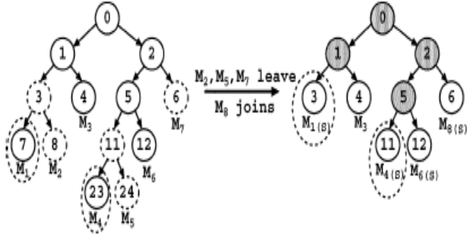
Figure 7.1 Logical Key Tree
Figure 7.1 is used to illustrate the LKT approach. Suppose that M₁ is the group controller. It first rekeys all renewed nodes as in the TGDH protocol. It then broadcasts to the group the following encrypted keys: {(K₀)₁, (K₀)₂, (K₁)₃, (K₁)₄, (K₂)₅, (K₂)₆, (K₅)₁₁, (K₅)₁₂}, where (K_{i}) _{j} refers to the secret key K_{i} of parent node i encrypted by the secret key K_{j} of the child node j. For example, in order for member M₃ to obtain the group key K₀, it first decrypts (K₁)₄ with K₄, followed by (K₀)₁ with K₁.
The group controller broadcasts the encrypted keys using the view synchronous communication model as in the interval-based algorithms. While the group controller can broadcast the encrypted keys via the point-to-multipoint multicast, such a communication, model has two limitations. First, if the underlying group communication is multipoint-to-multipoint-based such that every member can be a sender, setting up an extra multicast channel will be an overload. Also, it is possible for the group controller to leave the group. All other members have to detect the group controller’s departure and install a new membership view in order to select another group controller. The group controller’s departure, however, cannot be detected with the unilateral point-to-multipoint multicast. View synchrony is essential for reliable multipoint-to-multipoint group communication regardless of which group key management approach is being used.
The performance of the LKT approach can be quantified as follows. Since the encryption of the updated secret keys can be achieved with any inexpensive symmetric encryption algorithm, the computation cost of the LKT approach is mainly due to the exponentiation operations of renewing the secret keys. Furthermore, since the group controller uses the view-synchronous communication model as in the interval-based algorithms, the communication costs of the LKT approach and interval-based algorithms mainly differ by the number of keys (either encrypted or blinded) broadcast to the group and the number of rounds required to generate the group key.

TABLE 7.1 Paramter Table
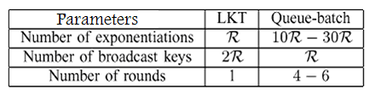
Table 7.1 compares the performance metrics of both LKT and Queue-batch schemes, where R denotes the number of renewed nodes, and the numbers of exponentiations and rounds for Queue-batch. As compared to our interval-based algorithms, the LKT approach requires fewer exponentiations and only one round to update the group key. However, all its exponentiations are carried out within the single group controller, while our interval-based algorithms scatter the computational load among all group members. In addition, the LKT approach broadcasts two encrypted copies of the updated secret key for each renewed node, while the interval-based algorithms broadcast only the corresponding blinded key. This implies that the interval-based algorithms save half of the number of broadcast keys. More importantly, the interval-based algorithms have better fault tolerance by eliminating the single-point-of-failure problem inherent in the centralized LKT approach.

- RESULTS AND ANALYSIS

Here an analysis of individual rekeying where, key tree is constructed for very membership event and interval based rekying is done. The following table illustrates number of computations that have taken place over a period of fifteen key interval runs. The time in between key daemon runs (T_{R}) is set to 3 ms.

TABLE 5.1 Comparison of both Rekeying Methods

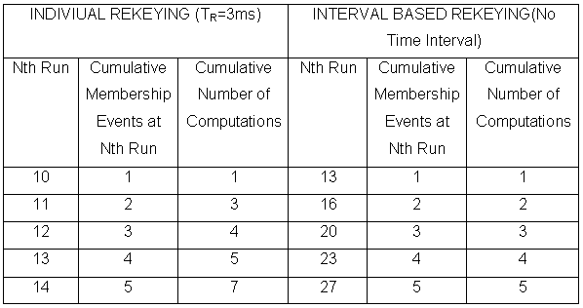

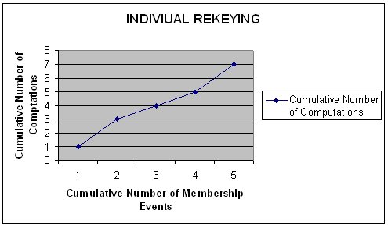
Figure 5.1 Individual Rekeying

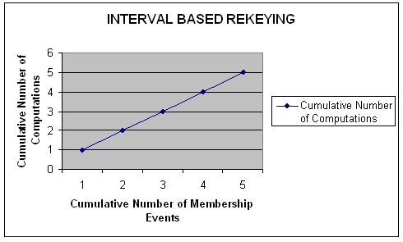
Figure 5.2 Interval based rekeying

From the above table and graphs one can infer that the number of computations for interval based rekeying is less than individual rekeying for the same number of membership events. Thus one can conclude that interval based rekeying algorithms outperform the individual rekeying technique. In addition to that they eliminate the single point of failure that occurs in centralized systems and provide good reliability

7. CONCLUSION

Several distributed collaborative key agreement protocols for dynamic peer groups have been implemented. The key agreement setting is performed in which there is no centralized key server to maintain or distribute the group key. From the implementation it can be shown that one can use the TGDH protocol to achieve such distributive and collaborative key agreement. To reduce the rekeying complexity, interval-based approach is used to carry out rekeying for multiple join and leave requests at the same time, with a tradeoff between security and performance. From the analysis, it’s evident that the Interval based algorithm can significantly reduce both computation and communication costs when there exists highly frequent membership events.

REFERENCES

[1] Patrick P. C. Lee, John C. S. Lui and David K. Y. Yau, April 2006, Distributed Collaborative Key Agreement and Authentication Protocols for Dynamic Peer Groups, IEEE/ACM Transactions on Networking, Vol. 14, pp 1-10

[2] Andrew S. Tanenbaum, 2001, “Computer Networks”, 3rd Edition Prentice Hall, Englewood cliffs.

[3] Andrew S. Tanenbaum, 2001, “Distributed Operating System”, 3rd Edition Pearson Education.

[4] William Stallings, 2003, “Cryptography and Network Security – Principles and Practices”, 3rd Edition, Pearson Education.

[5] Dane Nourie, May 2007, “Getting Started With the NetBeans IDE Tutorial”,
http://java.sun.com/developer/onlineTraining/tools.

[6] Y. Amir, Y. Kim, C. Nita-Rotaru, J. L. Schultz, J. Stanton, and G. Tsudik, May 2004, “Secure group communication using robust contributory key Agreement”, IEEE Transactions on. Parallel Distributed. Systems, pages. 1–30.

